**………….BLOOD BANK USING AJAX AND PHP………………**

* **Language are used:**

1. **Html**
2. **Bootstrap**
3. **Php**
4. **Ajax**
5. **Sql**

* **ALL Record page:**

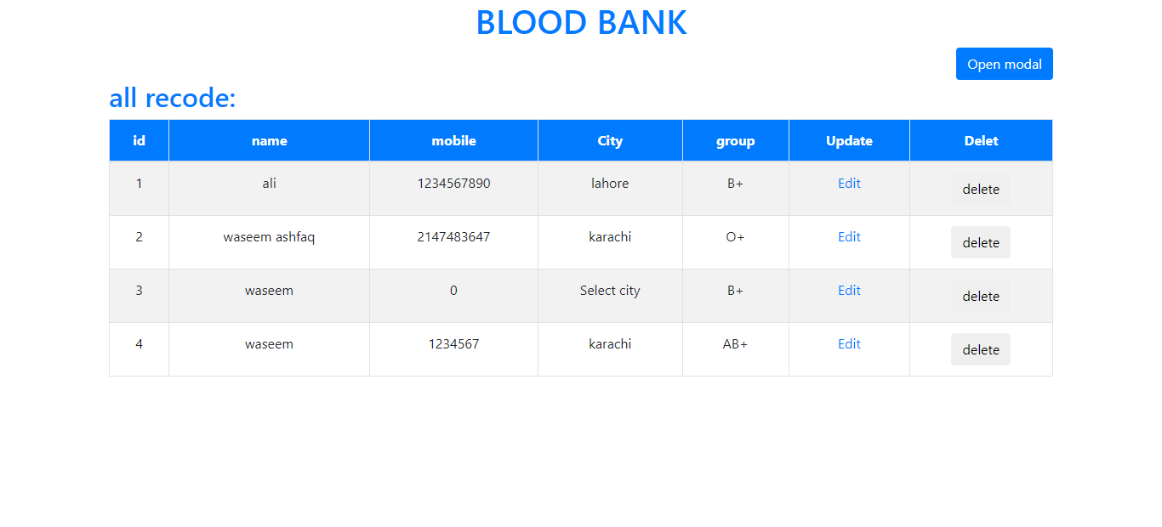

* **Edit user:**

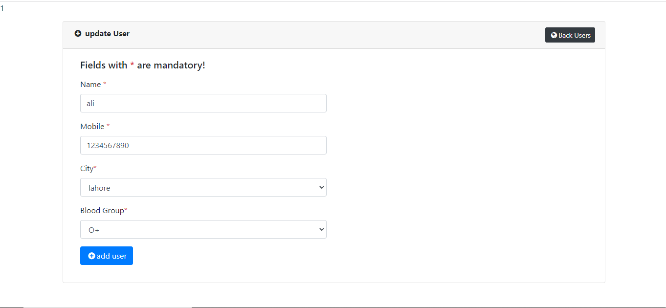

* **Add new user:**

Here is 2 drop down menu:

